**Flow**

**Advertiser creation and offer creation**

**Advertiser Signup**

Create a profile for Advertiser.

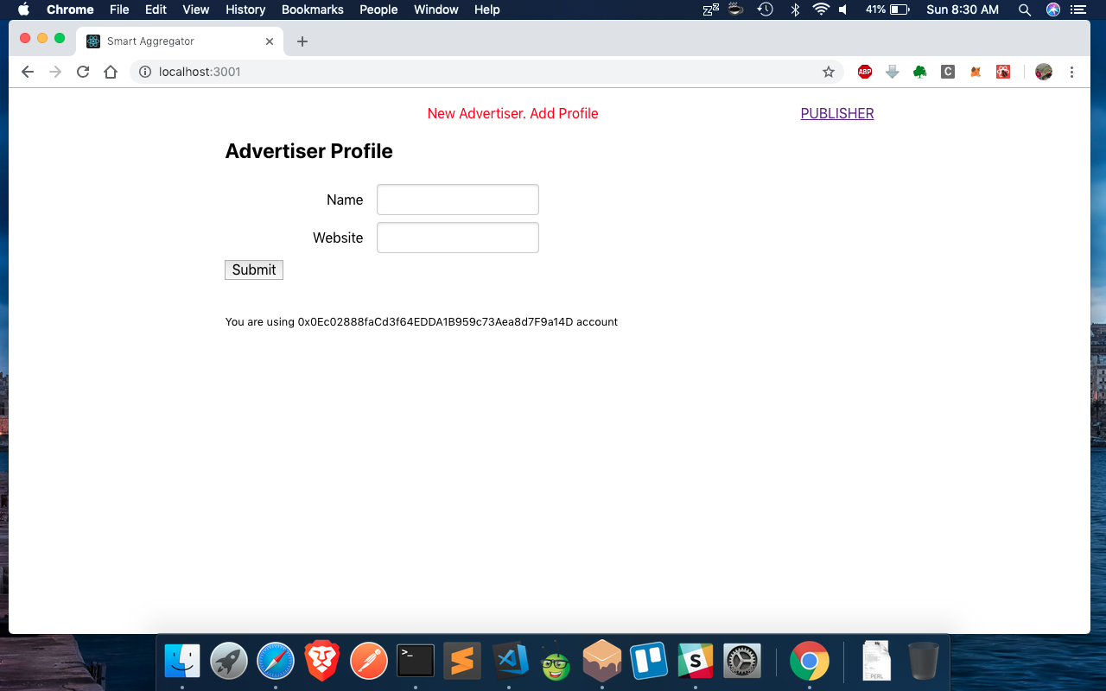

**Offer Creation**

Create an offer from the Advertiser Page.

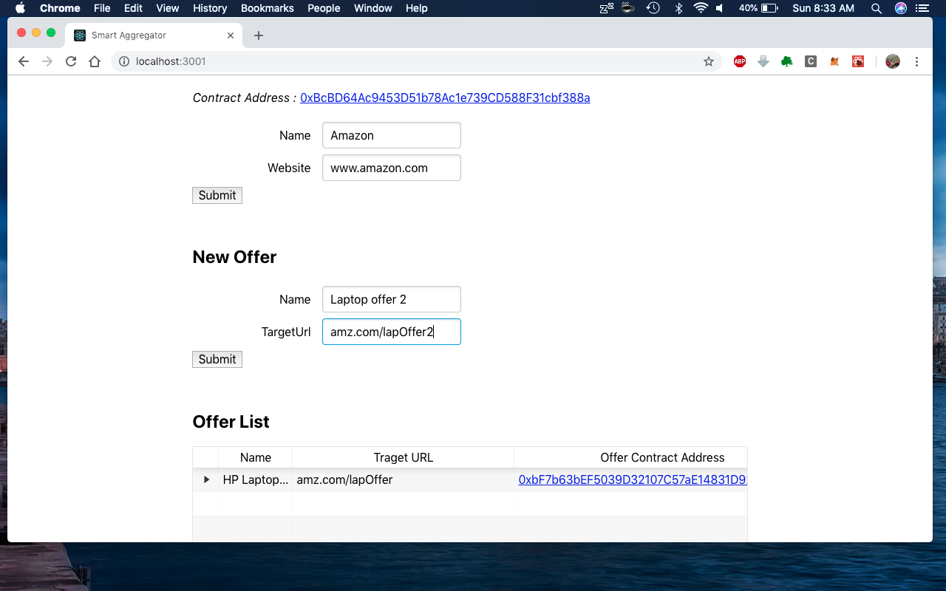

**Publisher creation and offer registration**

**Publisher Signup**

Create a profile for Publisher.

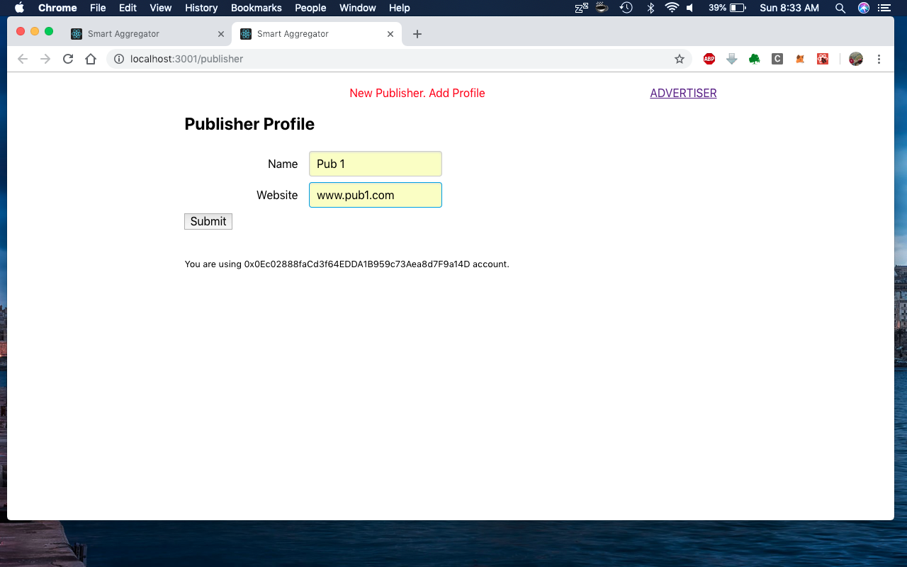

**Offer Registration**

Register to a offer from all the listed Advertiser offers.

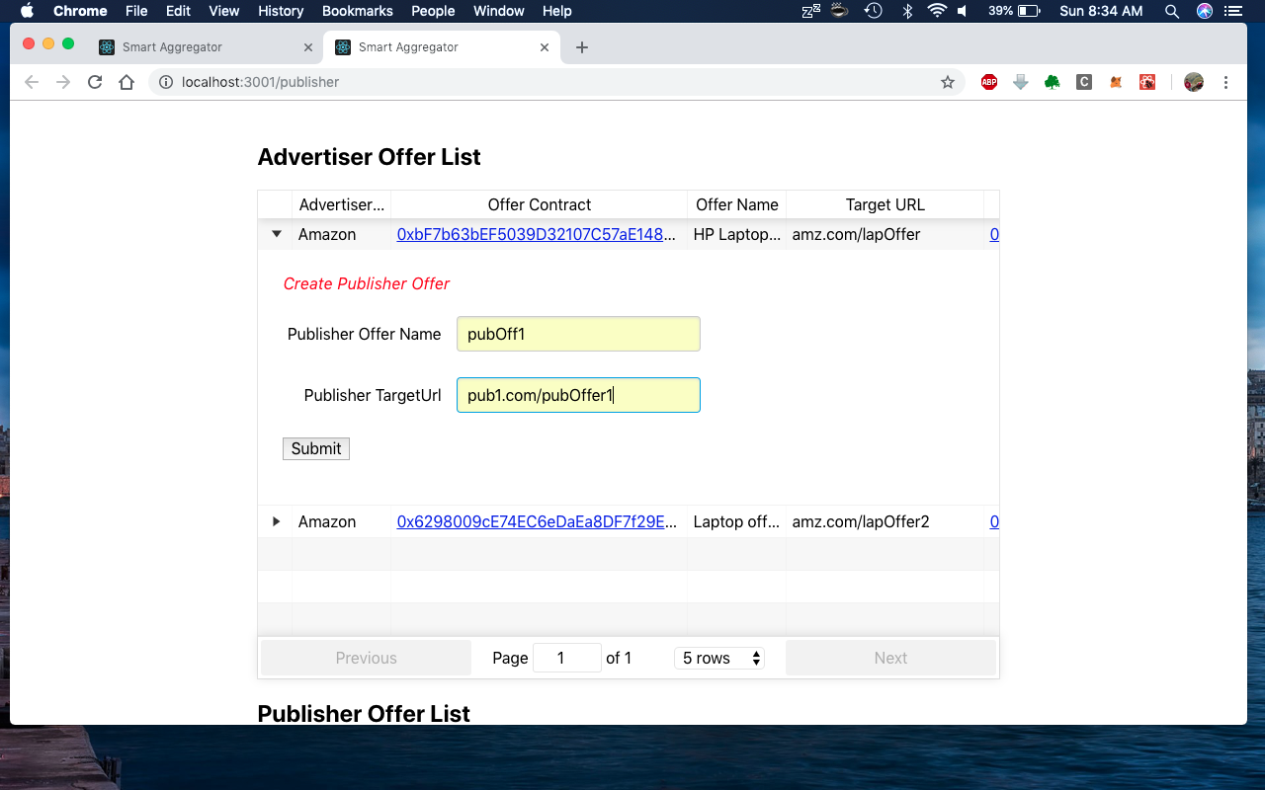

**Click generation**

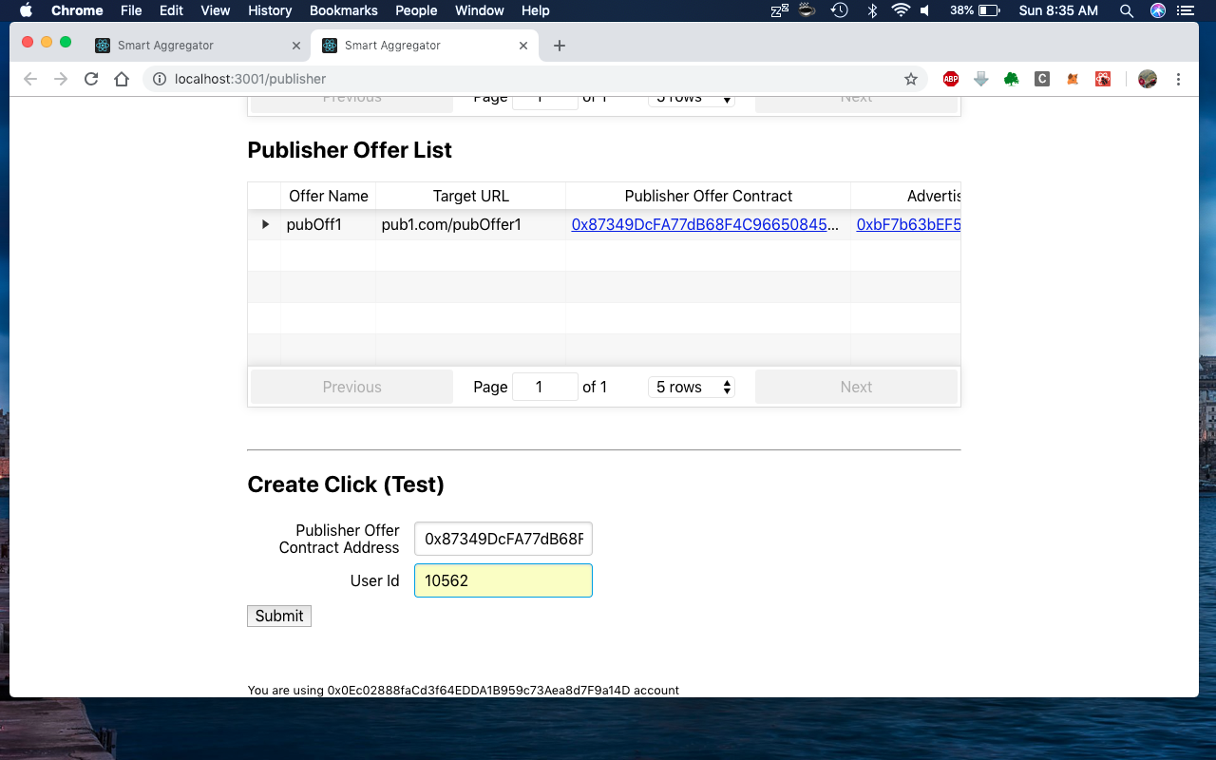

**Conversion generation**

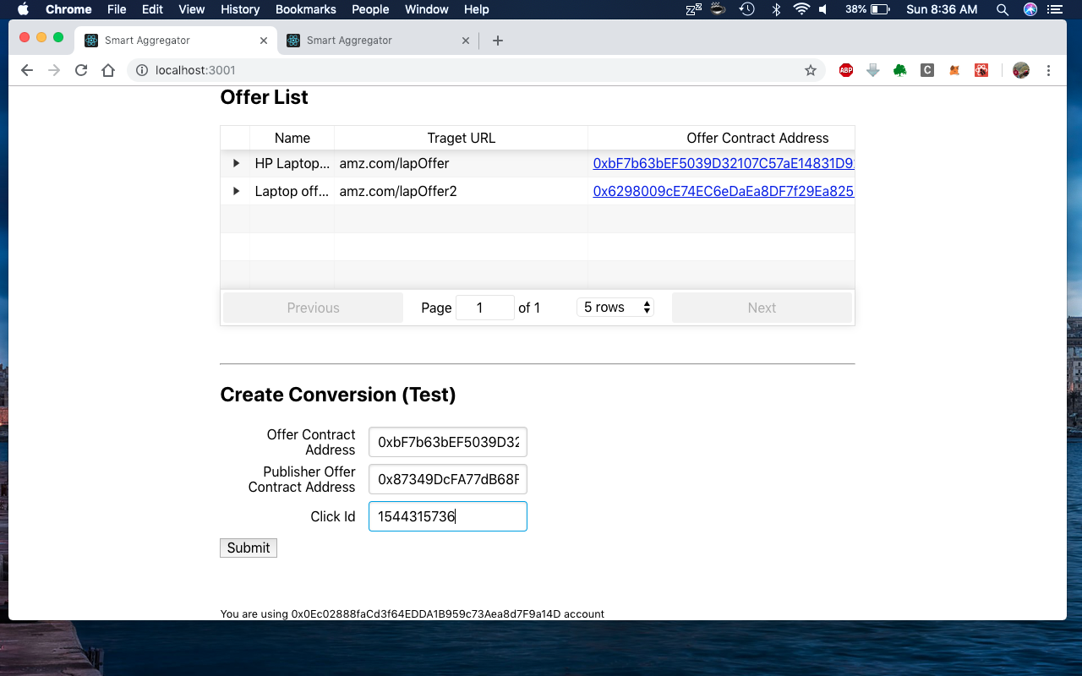

**Click and Conversion View in Publisher**

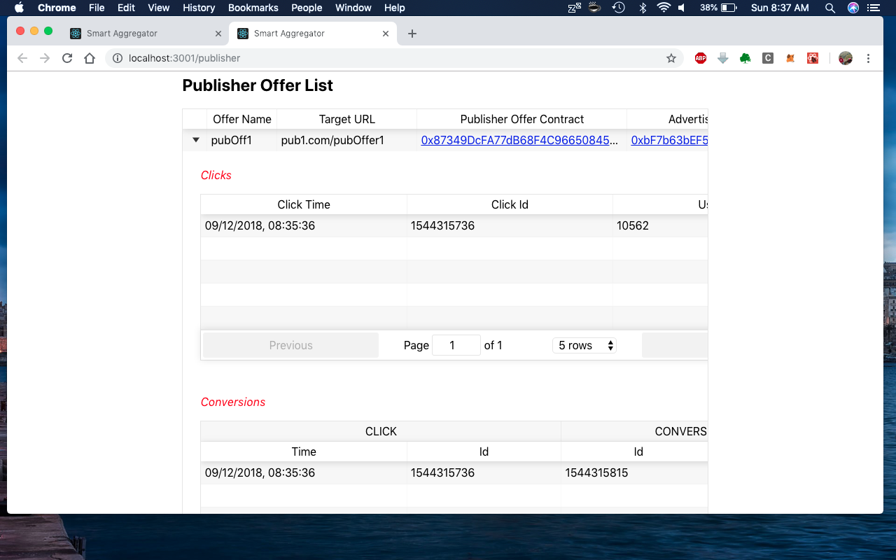

**Click and Conversion View in Advertiser**

